3 - Basics of Java Programming

1. Setting up the Environment (in Windows)
Step 1: Install JDK (Java Development Kit)
- Download the JDK from the Oracle website.
- Run the installer and follow the instructions to install the JDK.
Step 2: Set Up Environment Variables
- Open the Start menu, search for "Environment Variables," and select "Edit the system environment variables."
- In the System Properties window, click on the "Environment Variables" button.
- Under System Variables, click "New" and add a new variable:
  - Variable name: JAVA_HOME
  - Variable value: C:\Program Files\Java\jdk-<version>
- Find the Path variable, select it, and click "Edit." Add a new entry:
  - New entry: %JAVA_HOME%\bin
Step 3: Verify the Installation
- Open Command Prompt and type java -version and javac -version. You should see the version of Java installed.

Basic Syntax
Hello World Program
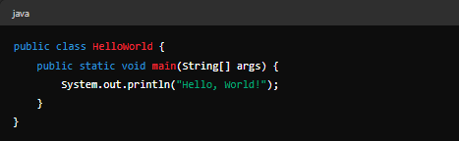
Explanation:

- public class HelloWorld: Defines a class named HelloWorld.
- public static void main(String[] args): The main method that runs when the program is executed.
- System.out.println("Hello, World!");: Prints "Hello, World!" to the console.
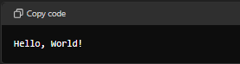
Output:

Data Types
Java has two categories of data types:
- Primitive Data Types: byte, short, int, long, float, double, boolean, char
- Non-Primitive Data Types: String, Arrays, Classes, Interfaces
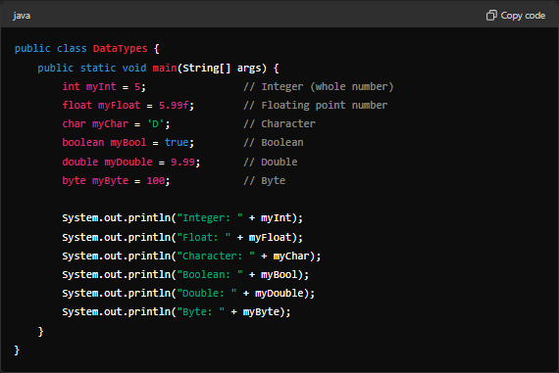
Example of Primitive Data Types

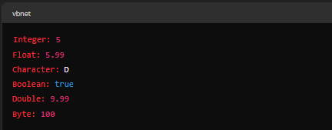
Output:

Primitive Data Types
Primitive data types are predefined by the Java language and named by a keyword. They serve as the building blocks for data manipulation. Java has eight primitive data types:
- byte
- short
- int
- long
- float
- double
- boolean
- char

Non-Primitive Data Types
Non-primitive data types are also called reference types because they refer to objects. They include classes, arrays, and interfaces. Non-primitive data types can be used to call methods to perform certain operations, while primitive data types cannot.
Java has multiple non-primitive datatypes –
- String
- Array
- Classes
- Interface

Operators in Java
Operators in Java are special symbols or keywords that perform operations on variables and values. Java operators can be categorized into the following types:
- Arithmetic Operators
- Unary Operators
- Relational Operators
- Logical Operators
- Bitwise Operators
- Assignment Operators
- Conditional (Ternary) Operator

1. Arithmetic Operators
Arithmetic operators are used to perform basic mathematical operations.
- + Addition
- - Subtraction
- * Multiplication
- / Division
- % Modulus (remainder)
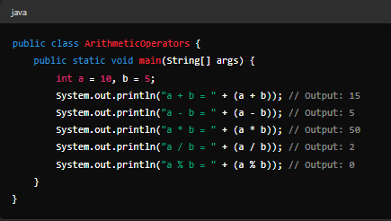

2. Unary Operators
Unary operators operate on a single operand.
- + Unary plus
- - Unary minus
- ++ Increment
- -- Decrement
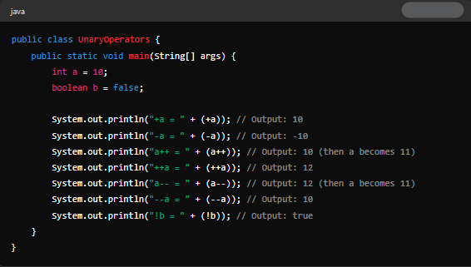
- ! Logical complement

3. Relational Operators
Relational operators (Conditional Operator) are used to compare two values.
- == Equal to
- != Not equal to
- > Greater than
- < Less than
- >= Greater than or equal to
- <= Less than or equal to
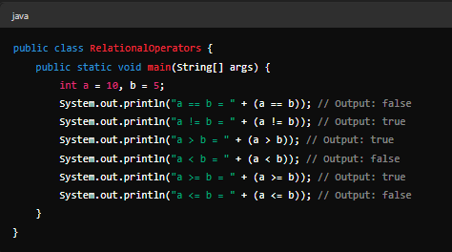

4. Logical Operators
Logical operators are used to combine multiple boolean expressions.
- && Logical AND
- || Logical OR
- ! Logical NOT
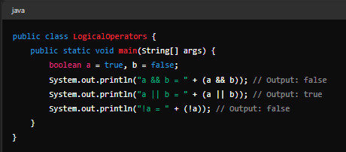

5. Bitwise Operators
Bitwise operators perform operations on bits of integer types.
- & Bitwise AND
- | Bitwise OR
- ^ Bitwise XOR
- ~ Bitwise complement
- << Left shift
- >> Right shift
- >>> Unsigned right shift
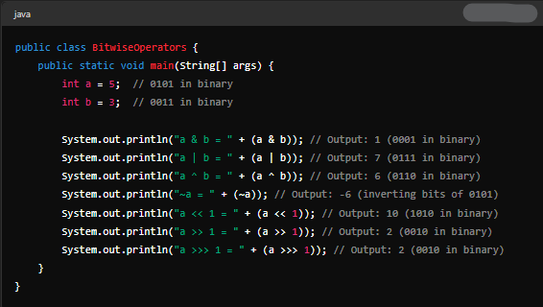

6. Assignment Operators
Assignment operators are used to assign values to variables.
- = Simple assignment
- += Add and assign
- -= Subtract and assign
- *= Multiply and assign
- /= Divide and assign
- %= Modulus and assign
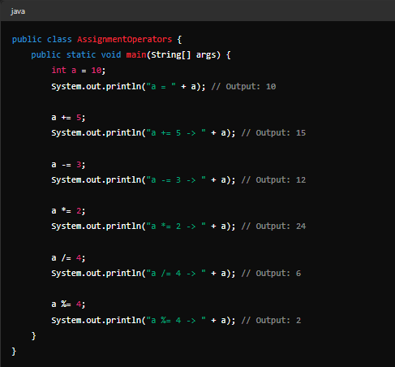

7. Conditional (Ternary) Operator
The conditional operator is a shorthand for the if-else statement.
- ? : Conditional (ternary) operator
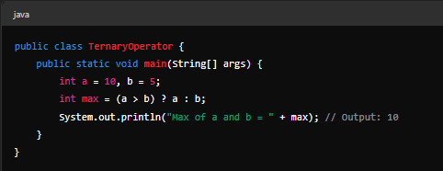

if Statement
The if statement is used to test a condition. If the condition evaluates to true, the block of code inside the if statement is executed.
Syntax:
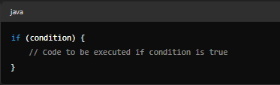
Example:
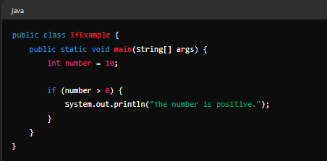
Output –
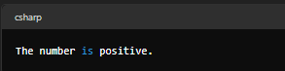

if-else Statement
The if-else statement provides an alternative block of code to be executed if the condition is false.
Syntax:
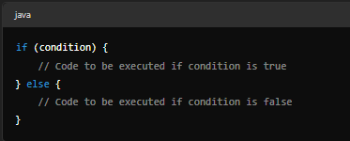
Example:
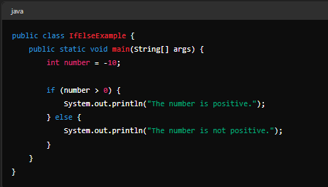
Output :
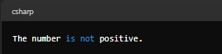

if-else-if Ladder
The if-else-if ladder statement is used to test multiple conditions. When a condition is true, the corresponding block of code is executed, and the rest of the ladder is skipped.
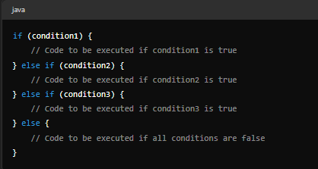
Syntax:

Example:
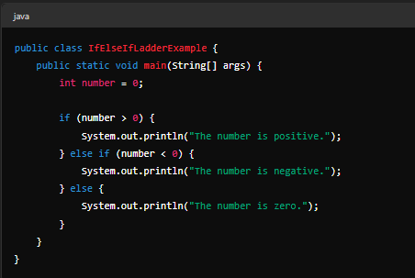
Output :
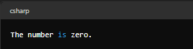

Nested if Statement
The nested if statement is an if statement inside another if statement. It allows for more complex conditions and logic.
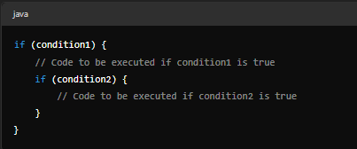
Syntax:

Example:
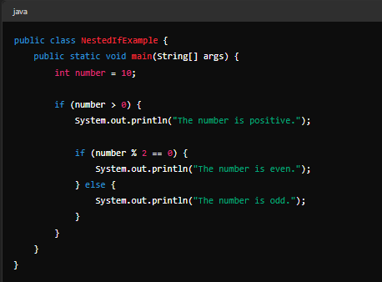
Output:
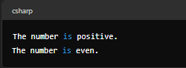

Switch Statement in Java
The switch statement is a control flow statement that allows you to execute one block of code among multiple options. It is often used as an alternative to using multiple if-else statements when you need to compare a single variable against several possible values.

1. Normal switch Statement
The switch statement in Java allows you to execute one block of code among many options. It is a better alternative to using multiple if-else statements.
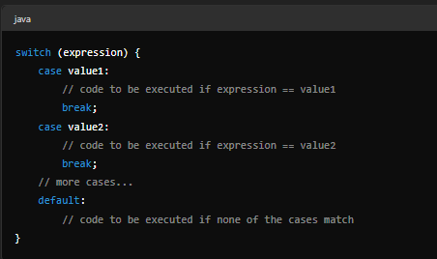
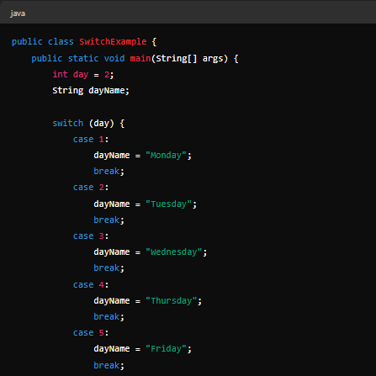
Example :
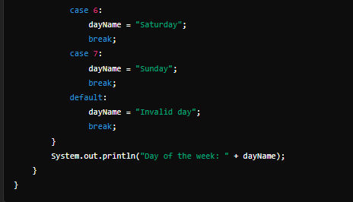
Output :
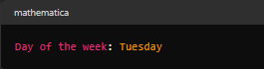

2. Fall-Through Condition
In a switch statement, if a break statement is not used, the execution falls through to subsequent cases. This means that all the following case statements are executed until a break is encountered or the end of the switch statement is reached.

3. Nested switch Statement
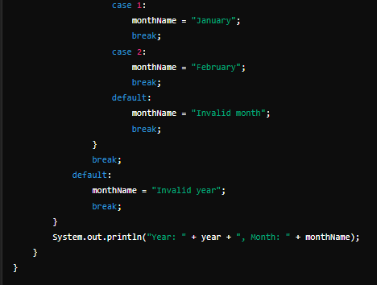
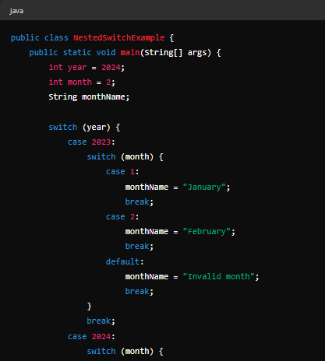
A switch statement can be nested within another switch statement. This allows for more complex decision-making structures.

Output –
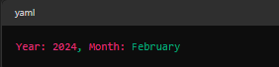

7. Arrays in Java
An array is a data structure that allows you to store multiple values of the same type in a single variable. Java provides different types of arrays: single-dimensional, multi-dimensional (such as two-dimensional arrays), and jagged arrays.

1. Single-Dimensional Arrays
A single-dimensional array, also known as a one-dimensional array, stores elements in a linear sequence.
Syntax:
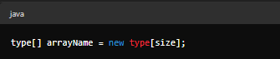
Example:
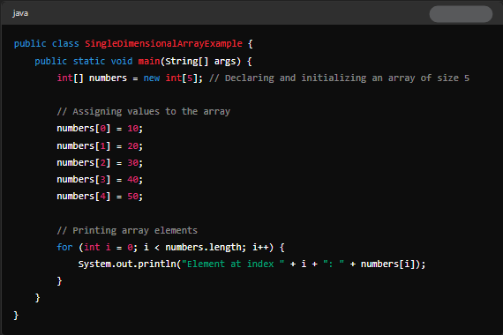
Output:
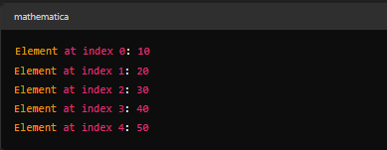

2. Multi-Dimensional Arrays
A multi-dimensional array can be visualized as a table (or matrix) of elements. The most commonly used multi-dimensional array is the two-dimensional array.
Syntax:
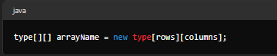
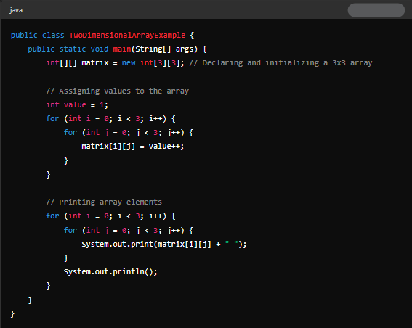
Example:
Output –
